**Locker Project**

* **Content**

1. Project and Developer Details
2. Sprints Planned and the Tasks Achieved in them
3. Algorithms and Flowcharts of the Application
4. Core Concepts Used in the Project
5. Functionality & Features of Locker Project
6. Links to the GitHub Repository
7. Your conclusion on enhancing the application and defining the USPs

**1. Project and Developer Details**

**Project Objective ->**

* As a Full Stack Developer, complete the features of the application by planning the development in terms of sprints and then push the source code to the GitHub repository. As this is a prototyped application, the user interaction will be via a command line.

**Application Features ->**

* The first option should return the current file names in ascending order. The root directory can be either empty or contain few files or folders in it
* The second option should return the details of the user interface such as options displaying the following:
  + Add a file to the existing directory list
    - You can ignore the case sensitivity of the file names
  + Delete a user specified file from the existing directory list
    - You can add the case sensitivity on the file name in order to ensure that the right file is deleted from the directory list
    - Return a message if FNF (File not found)
  + Search a user specified file from the main directory
    - You can add the case sensitivity on the file name to retrieve the correct file
    - Display the result upon successful operation
    - Display the result upon unsuccessful operation
  + Option to navigate back to the main context
* There should be a third option to close the application

**Developer Details ->**

1. **Name :** Shreyash Vijay Pawar
2. **Designation :** Developer
3. **IDE used :** Eclipse

**2. Sprints Planned and the Tasks Achieved in them**

|  |  |  |  |  |  |  |
| --- | --- | --- | --- | --- | --- | --- |
| Sprint | Task | Developer | Estimated Time (Hrs) | Actual Time (Hrs) | Remaining Time (Hrs) | Status |
| #1 | Analysis Finished | Shreyash | 1 | 1 | 0 | Complete |
| Document Current System | Shreyash | 1 | 1 | 0 | Complete |
| Get All Files Functionality | Shreyash | 2 | 2 | 0 | Complete |
| Add New File Functionality | Shreyash | 3 | 3 | 0 | Complete |
| #2 | Delete Existing File Functionality | Shreyash | 1 | 1 | 0 | Complete |
| Search Existing File Functionality | Shreyash | 2 | 2 | 0 | Complete |
| Overwrite Existing File While Adding | Shreyash | 2 | 2 | 0 | Complete |
| Documentation | Shreyash | 2 | 2 | 0 | Complete |

**3. Algorithms and Flowcharts of the Application**

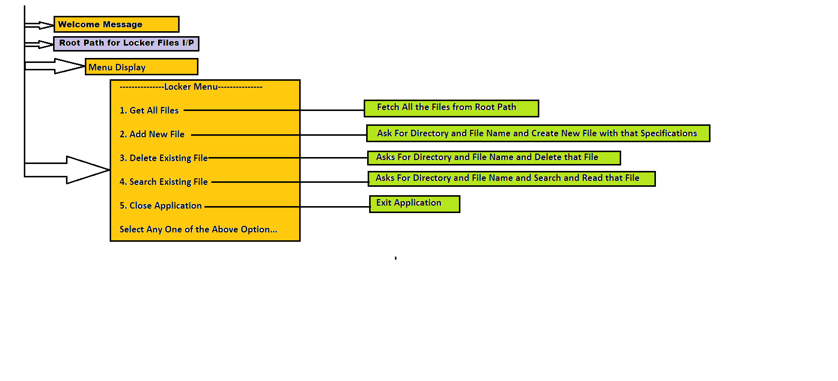

**4. Core Concepts Used in the Project**

1. Variables
2. Data types
3. Operators
4. Methods
5. Control Structures
6. Objects
7. Exceptions
8. Collections
9. File Handling

**5. Functionality & Features of Locker Project**

**A. Welcome Page and Root Path Input**

* Welcome page will appear and system will ask for root rath for Locker Files Management system.
* For invalid input path it will ask to try again with different root path.

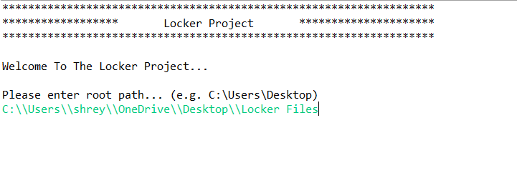

**B. Menu Options**

* Once user entered valid root path, menu options will be displayed and user can select any option from 1 to 5.
* For all inputs other than valid input options (i. e. 1 to 5), system will ask user to try again with valid input option

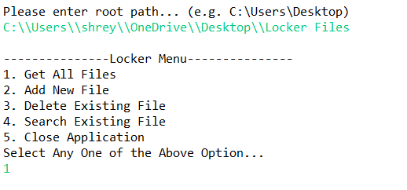

1. **Get All Files**

* Select **Option 1 Get All files.**
* It will list all the files present in root and nested paths and then it will take user back to main menu.

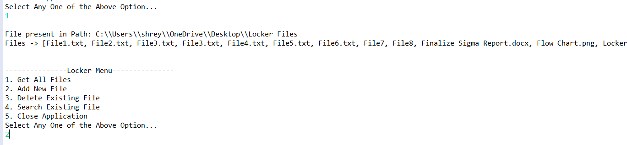

1. **Add New File**

* Select **Option 2 Add New File**.
* System will ask user to enter directory/file name.
* If any of this does not exist system will ask if user wants to create it. If yes, system will create directory/file or else it will take user back to main menu.

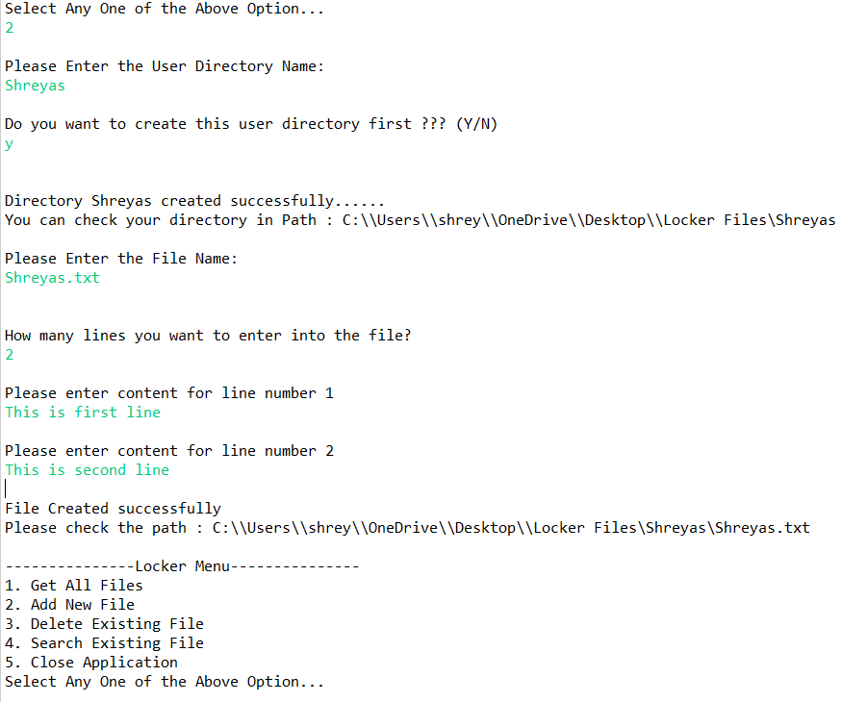

* If file already exists, system will ask if user wants to overwrite the existing file (Y/N).
* If yes, then System will overwrite existing file with new content. Then it will take user back to main menu.

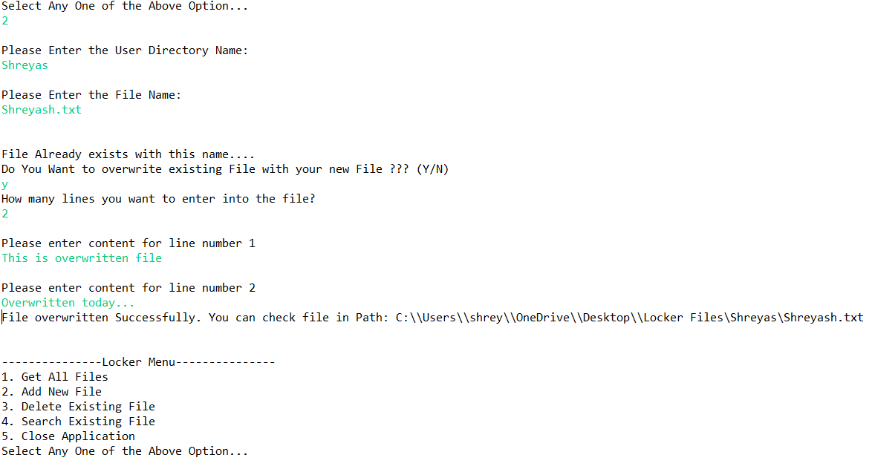

1. **Delete Existing File**

* Select **Option 3 Delete Existing File**.
* System will ask user to enter directory/file name.
* If any of this does not exist system will ask if user want to try with some another directory/file (Y/N). Then system will delete file mentioned by user and it will take user back to main menu.

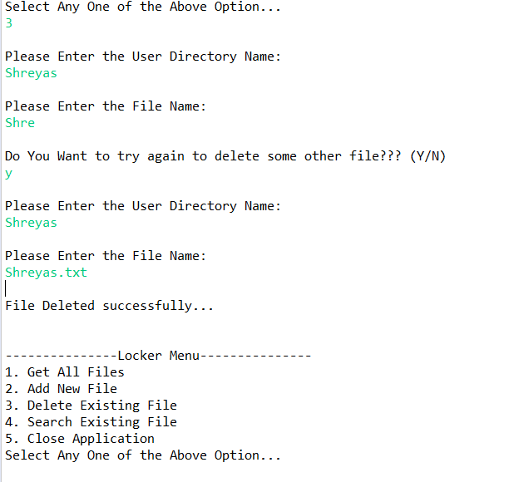

1. **Search Existing File**

* Select **Option 4 Search Existing File**.
* System will ask you to enter directory/file name.
* If any of this does not exist system will ask if user wants to try with some another directory/file.
* System will fetch user mentioned file and it will ask user if user wants to see the content of this file (Y/N).
* If yes, it will display content or else it will take user back to main menu.

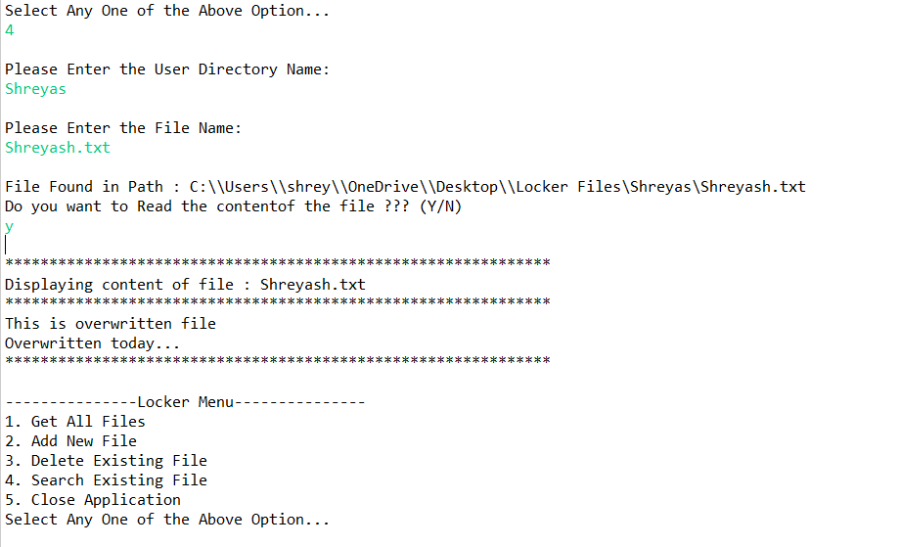

1. **Close Application**

* Select **Option 5 Close Application**.
* System will display thank you message and terminate the application.

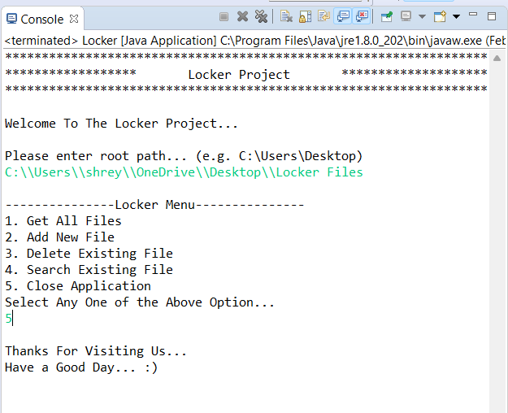

**6. Links to the GitHub Repository**

1. **Link:** https://github.com/ShreyashVijayPawar/LockerProject.git
2. **File:** LockerProject/src/locker_project/Locker.java
3. **Note:** Code present in master branch

**7. Your conclusion on enhancing the application and defining the USPs (Unique Selling Points)**

1. **Enhancements –**

* Option to append the content to existing file.
* Option to move file in between directories.

1. **Unique Selling Points (USP)**

* User Friendly Application
* Versatile and Scalable